Responsibility Description

|  |  |  |
| --- | --- | --- |
| Responsibility Description | Type | Concept name |
| Rs1:Users add data to the database | D | DataAdd |
| Rs2:users choose to query database | D | DataQuery |
| Rs3:Call the database data and deal with the data in a certain way | D | DataProcessing |
| Rs4:The processed data is presented as a graph for users to query and watch | D | ChartGeneration |
| Rs5:Store charts for viewing at any time | D | DataStorage |
| Rs6:Display different charts to users and select previous charts | K | ContentDisplaying |

Sequence Diagram

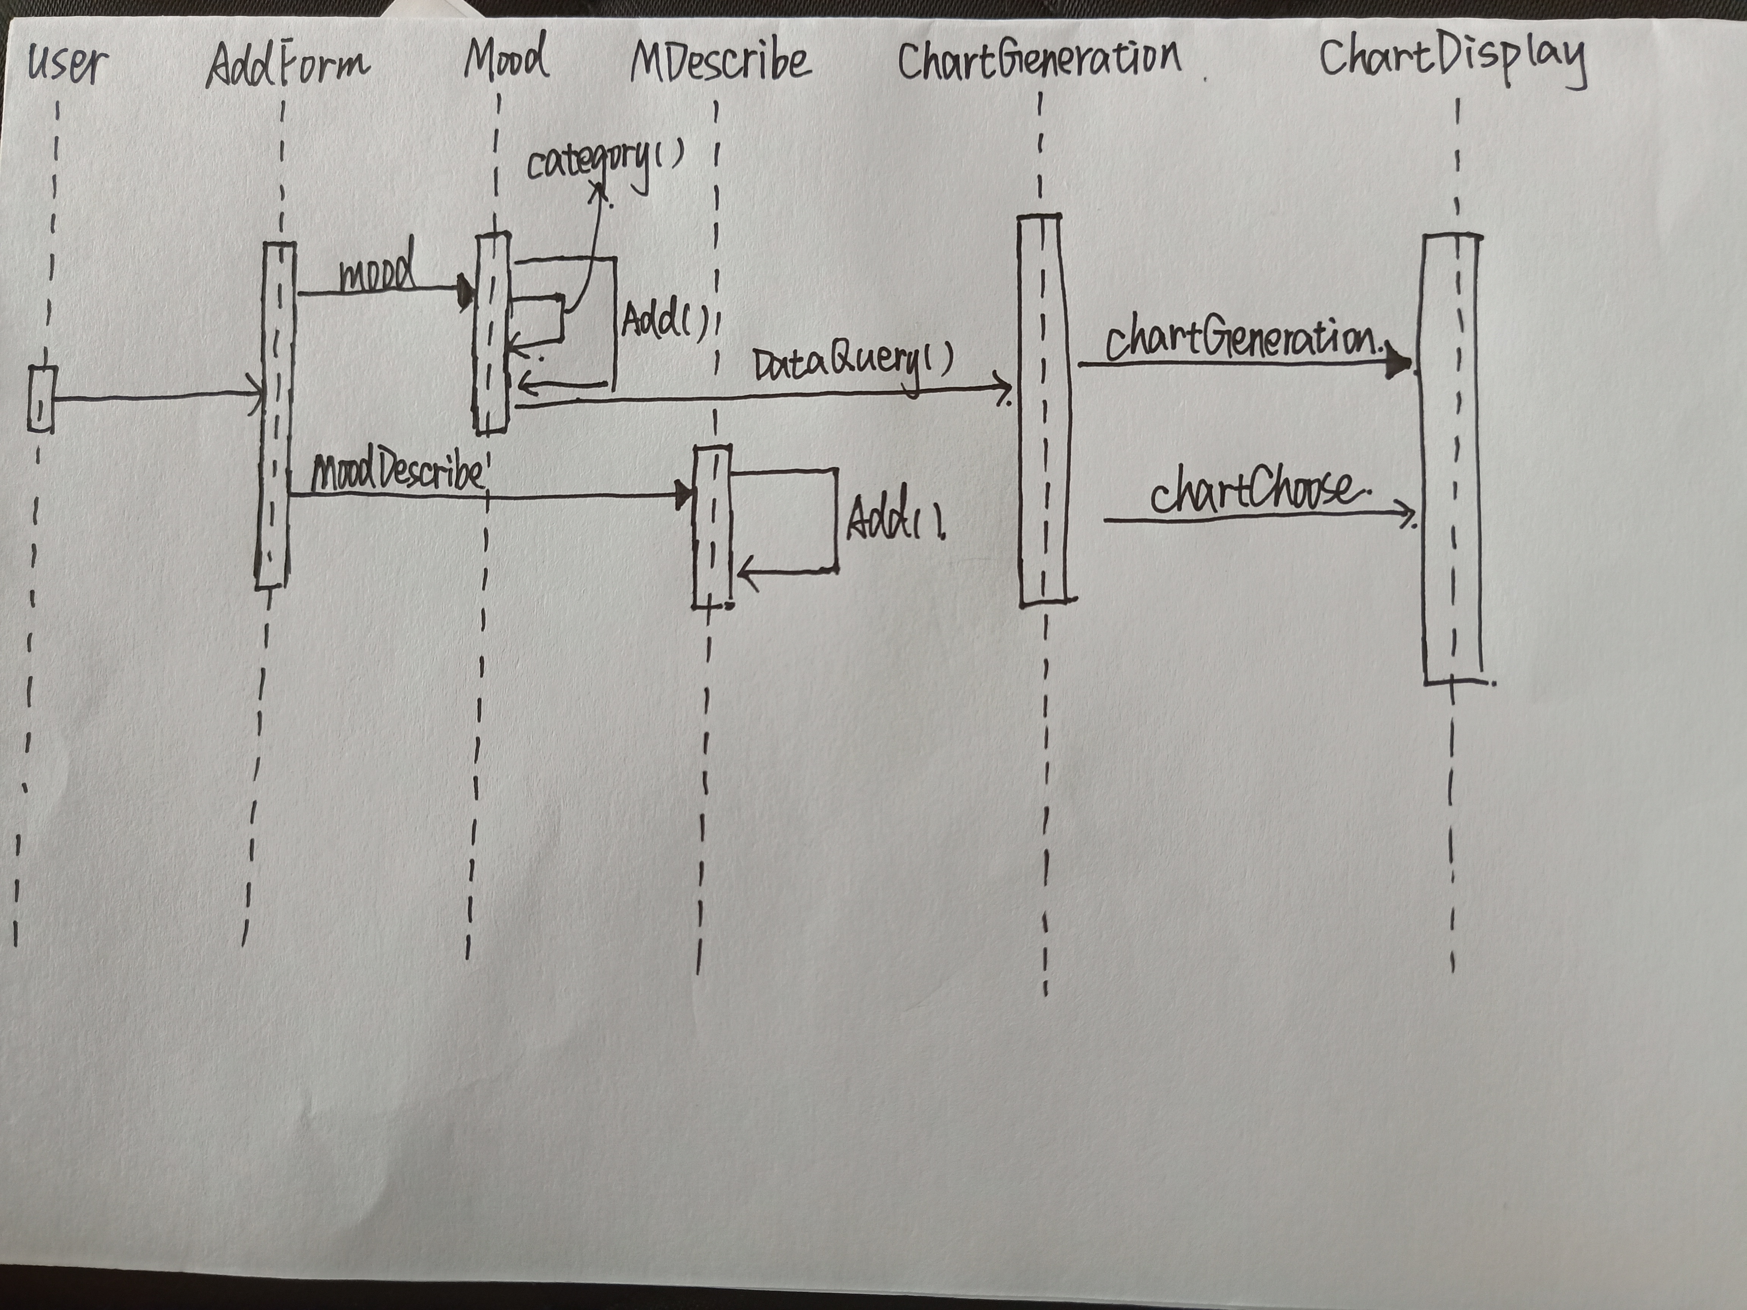

Class Diagram

